CHAPTER THREE
SYSTEM ANALYSIS AND METHODOLOGY
3.1 Analysis of the Existing System
The analysis of the existing system is a critical phase that involves a detailed study of the current operations to identify inefficiencies and areas for improvement. In the context of maternal health in Nigeria, the existing system is predominantly manual and paper based. This involves the physical recording of patient data in case files and registers which are stored in cabinets within the hospital.
3.1.1 Description of the Existing Maternal Health Monitoring Process
The current maternal health monitoring process operates on a scheduled appointment basis. A pregnant woman registers at the antenatal clinic and receives a physical card that serves as her medical record. During each visit, nurses manually measure vital signs such as blood pressure, weight, and temperature, recording them in both the hospital register and the patient's card. This process requires the physical presence of the patient at the healthcare facility. If a patient experiences symptoms like sudden weight gain or reduced fatal movement at home, she must travel to the hospital to report these changes. There is no formal mechanism for continuous monitoring outside the hospital premises. The communication flow is strictly one way during visits, with doctors reviewing the data only when the patient is sitting in front of them (Oluwaseun & Musa, 2022).
3.1.2 Problems of the Existing System
The existing manual system is plagued by several inherent problems that compromise the quality of maternal care. Firstly, the reliance on paper records makes data retrieval tedious and time consuming. Files can be misplaced, damaged, or duplicated, leading to fragmented patient history. Secondly, the system is reactive rather than proactive. Health deteriorations that occur between scheduled visits often go undetected until they become critical emergencies. For instance, a spike in blood pressure indicating the onset of preeclampsia may not be identified until the next fortnightly or monthly appointment. Additionally, the illegibility of handwriting by different health personnel can lead to misinterpretation of medical data, potentially resulting in wrong diagnosis or treatment plans (Amadi et al., 2023).
3.1.3 Challenges Faced by Pregnant Women and Healthcare Providers
Pregnant women face significant challenges with the current system, primarily related to accessibility and cost. The need to physically travel to the clinic for every routine check imposes a financial burden due to transportation costs, especially for those in rural areas. Long waiting times at overcrowded clinics also lead to fatigue and stress, which are detrimental to maternal health. For healthcare providers, the challenge lies in workload management. Doctors are often overwhelmed by the volume of patients they must see physically, leaving little time for in depth analysis of each case. The inability to monitor high risk patients remotely means that doctors cannot prioritize care effectively, leading to burnout and reduced efficiency in service delivery (Ibrahim & Yusuf, 2021).
3.2 Proposed System
The proposed system is a web based maternal health remote monitoring application designed to address the limitations of the manual process. It leverages internet technology to create a bridge between the patient and the healthcare provider.
3.2.1 Description of the Proposed Maternal Health Remote Monitoring System
The proposed system is an automated platform developed using PHP and SQL that allows pregnant women to log their daily health vitals via a user-friendly interface. Accessible on smartphones and computers, the system enables patients to input data such as blood pressure readings, body weight, and fetal kick counts. This data is instantly transmitted to a secure central database. On the other end, doctors access a dedicated dashboard where they can view real time charts and trends of their patients' health. The system includes an intelligent alert feature that highlights abnormal readings, prompting the doctor to contact the patient immediately. This digital approach transforms antenatal care from a periodic event into a continuous process.
3.2.2 Objectives of the Proposed System
The primary objectives of the proposed system are to ensure real time tracking of maternal health indicators and to facilitate timely medical interventions. Specifically, the system aims to provide a secure repository for maternal health records, eliminating the risk of data loss associated with paper files. It also seeks to reduce the frequency of physical hospital visits for routine monitoring, thereby decongesting healthcare facilities. Another key objective is to empower women with visual insights into their own health progress, fostering better engagement with their pregnancy journey.
3.2.3 Advantages of the Proposed System
The advantages of the proposed system over the existing one are manifold. It offers convenience by allowing women to conduct routine checks from the comfort of their homes. It improves the speed of care delivery, as doctors can assess patient status without a physical meeting. The system enhances data accuracy by removing the errors associated with manual transcription. Furthermore, it creates a digital audit trail that is useful for medical research and hospital administration. Economically, it reduces the out-of-pocket expenses for patients related to transport and saves hospital resources by streamlining patient flow (Chukwu & Eze, 2024).
3.2.4 Justification for the Proposed System
The justification for this system lies in its potential to save lives. With maternal mortality rates remaining high, shifting to a digital monitoring model aligns with global best practices for preventative healthcare. The system is justified by its ability to bridge the gap caused by the shortage of healthcare personnel in Nigeria. By automating the monitoring of stable patients, limited medical resources can be focused on those requiring acute care. This technological intervention is a necessary step towards modernizing the Nigerian healthcare infrastructure and achieving better health outcomes for mothers and babies.
3.3 System Requirements
System requirements definition is a crucial step that outlines what the system must do and the constraints under which it must operate.
3.3.1 Functional Requirements
Functional requirements describe the specific behaviours and functions of the system.
- User Registration and Authentication: The system shall allow patients and doctors to create accounts and log in securely.
- Vital Sign Logging: The system shall allow patients to input blood pressure, weight, and fatal movement data.
- Dashboard Visualization: The system shall display patient data in tabular and graphical formats for doctors.
- Alert Generation: The system shall automatically flag readings that exceed defined safety thresholds.
- Profile Management: The system shall allow users to update their personal and contact information.
- Reporting: The system shall generate summary reports of a patient's health over a specific period.
3.3.2 Non-Functional Requirements
Non-functional requirements specify the quality attributes of the system.
- Security: The system must ensure that all patient data is stored securely and protected against unauthorized access.
- Availability: The system should be available 24 hours a day to allow for logging at any time.
- Usability: The user interface must be intuitive and easy to navigate for users with basic digital literacy.
- Responsiveness: The system must function correctly on various screen sizes, including mobile phones and tablets.
- Performance: The system should process data submissions and load dashboards without significant delay.
3.4 Research Methodology
The research methodology outlines the systematic approach adopted to conduct the study and develop the solution.
3.4.1 Research Design
This study adopts the Applied Research Design, specifically focusing on software development. This design is appropriate because the study aims to solve a practical problem through the creation of a technological tool. The research moves beyond theoretical analysis to the actual construction and testing of a software artifact that addresses the identified issues in maternal health monitoring.
3.4.2 Data Collection Methods
Primary data was collected to understand the specific needs of the users. This involved semi structured interviews with healthcare professionals to understand clinical requirements for monitoring. Additionally, observation methods were used at a local antenatal clinic to understand the workflow and pain points of the current manual system. Secondary data was sourced from academic journals, textbooks, and WHO reports dated from 2020 to the present to establish the theoretical foundation.

3.4.3 Population of the Study
The population of the study comprises pregnant women attending antenatal clinics in the selected study area and the obstetricians or midwives attending to them. This population was chosen because they are the direct beneficiaries and users of the proposed system.
3.4.4 Sample Size and Sampling Technique
A purposive sampling technique was employed to select thirty pregnant women and five healthcare providers for the requirement gathering phase. Purposive sampling was suitable as it allowed the researcher to select participants who have access to smartphones and are willing to participate in a digital health study, ensuring that the gathered data is relevant to the proposed technology.
3.4.5 Method of Data Analysis
The data gathered from interviews and observations were analysed using qualitative methods. The requirements were categorized into functional and non-functional groups to guide the system design. The software development aspect utilized the logical analysis of data flow to structure the database and application logic.
3.5 System Design Methodology
3.5.1 Development Methodology
The Object-Oriented Analysis and Design (OOAD) methodology was adopted for the development of the system. OOAD is preferred because it models the system as a collection of interacting objects, such as Patients, Doctors, and Vitals, which maps directly to the real-world healthcare environment. This approach promotes modularity and reusability of code. The software development life cycle followed an iterative model, allowing for the refinement of features based on initial testing.

3.5.2 System Architecture Design
The system is built on a Three Tier Architecture comprising the Presentation Tier, the Logic Tier, and the Data Tier.
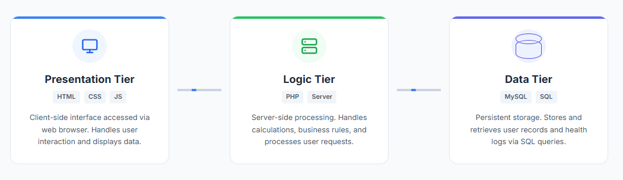
System Active: Data flowing between tiers.
3.6 System Flowchart
The system flowchart is a graphical representation of the logical sequence of steps and decisions involved in the operation of the maternal health remote monitoring system. It illustrates the navigation path a user takes from the start of the application to the completion of a task.

3.6.1 Description of the System Flowchart

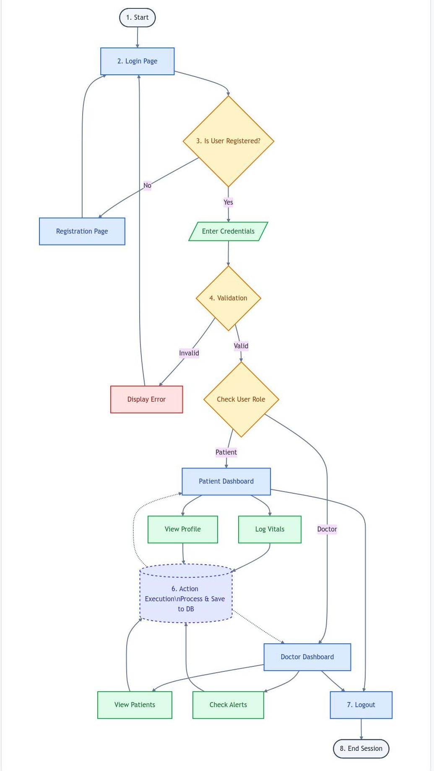
Figure 3.1: System Flowchart
3.7 Data Flow Diagram (DFD)
The Data Flow Diagram visualizes the movement of information within the system. It maps out the flow of data from external entities into the system processes and data stores.
3.7.1 Context Diagram
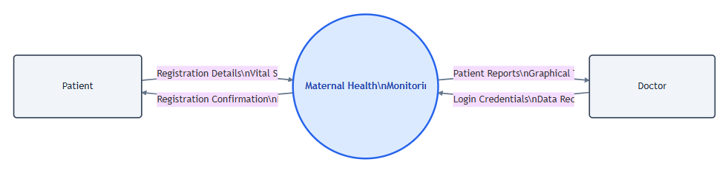
Figure 3.2: Context Diagram of the Proposed System
3.7.2 Level 0 DFD
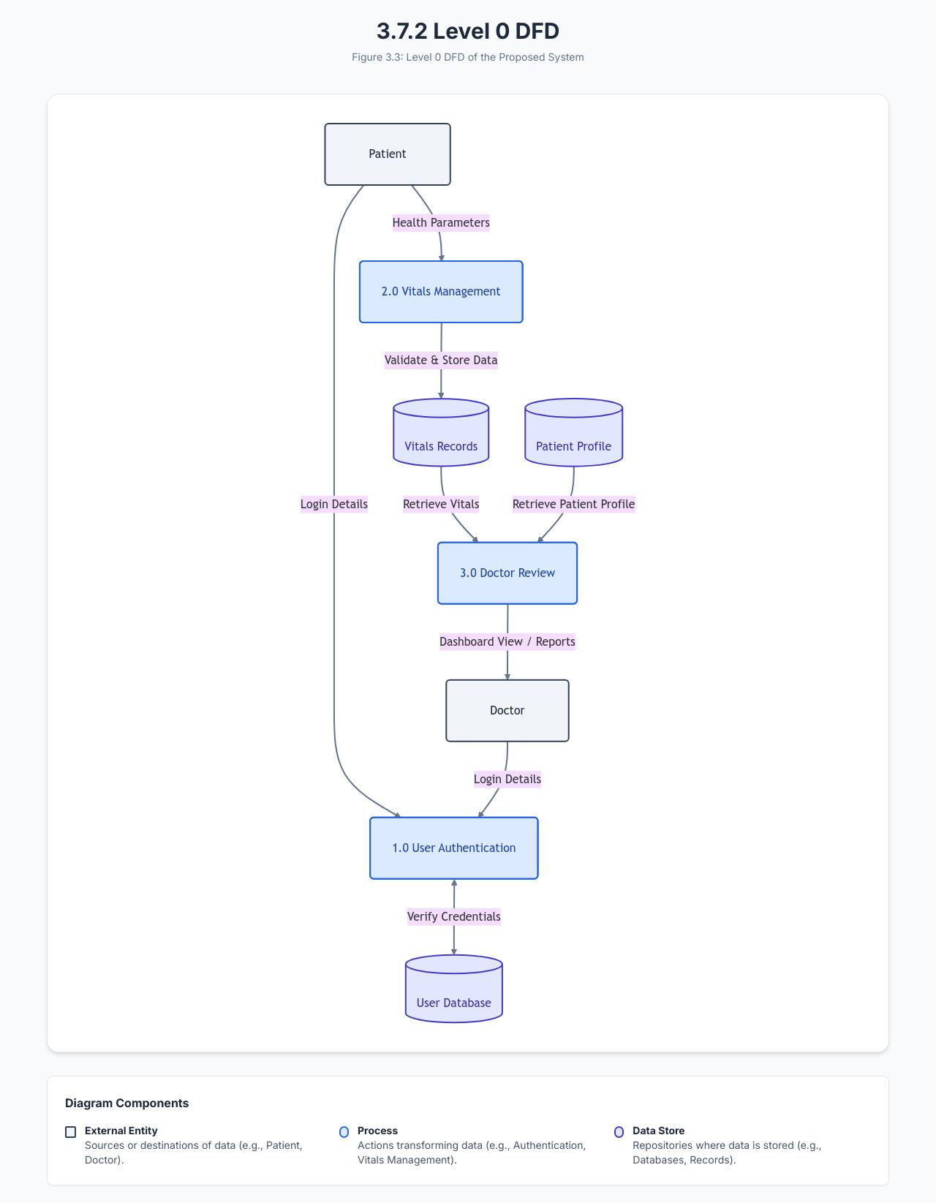
Figure 3.3: Level 0 DFD of the Proposed System

3.7.3 Level 1 DFD
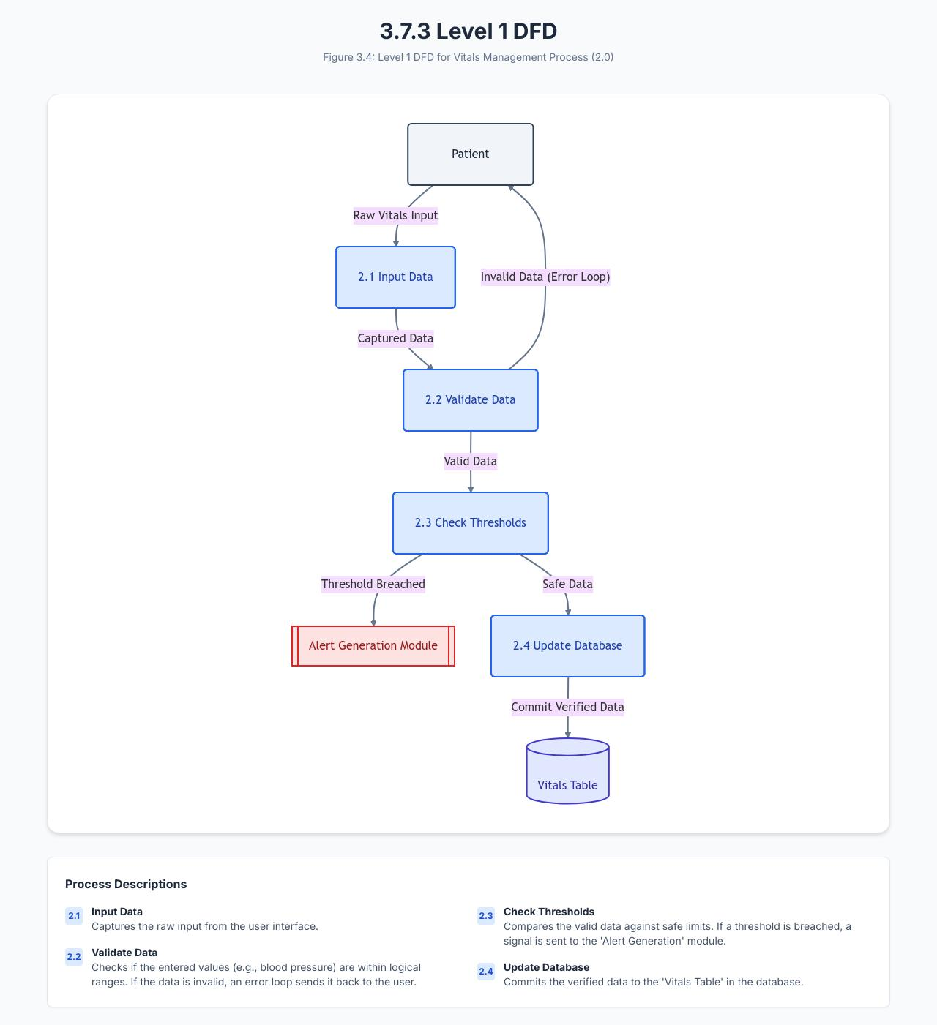
Figure 3.4: Level 1 DFD for Vitals Management Process
3.8 Unified Modelling Language (UML) Diagrams
UML diagrams provide a standardized way to visualize the design of the system, capturing both static structure and dynamic behaviour.
3.8.1 Use Case Diagram
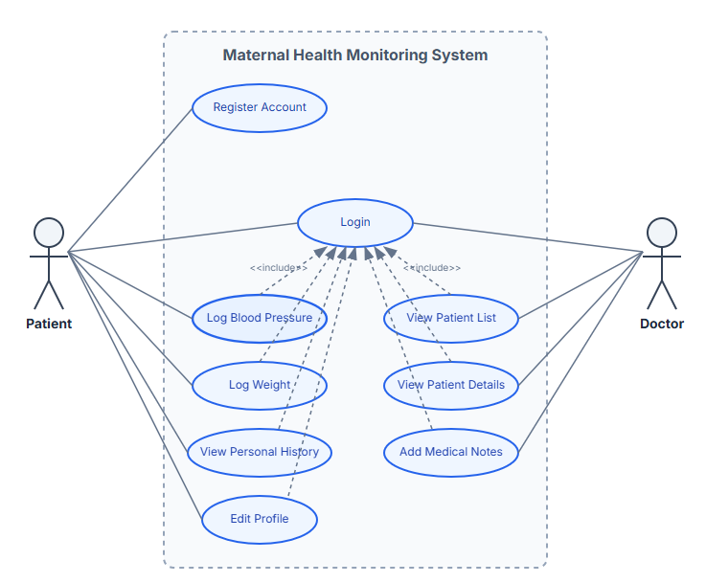
Figure 3.5: Use Case Diagram
3.8.2 Class Diagram
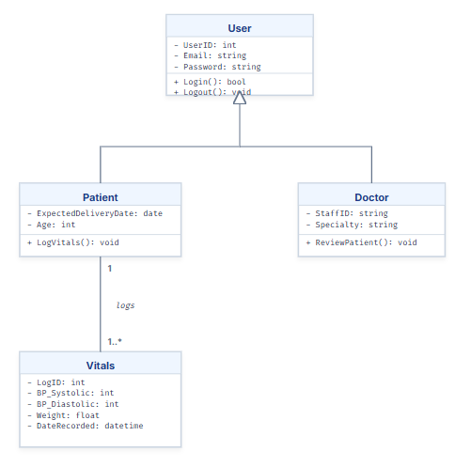
Figure 3.6: Class Diagram
3.8.3 Sequence Diagram
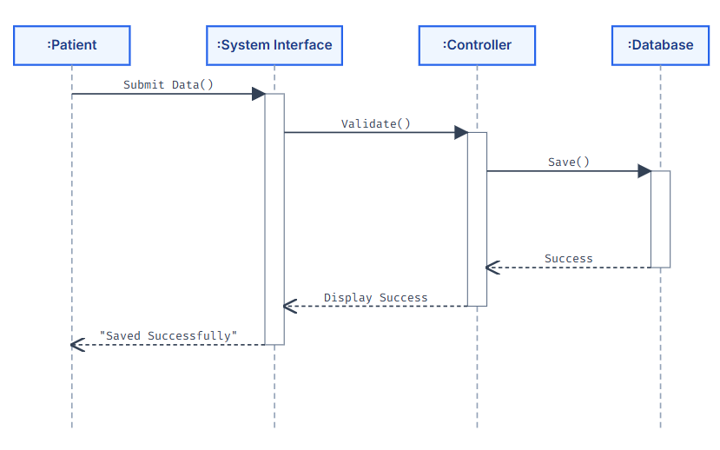
Figure 3.7: Sequence Diagram for Log Vitals Scenario
3.8.4 Activity Diagram
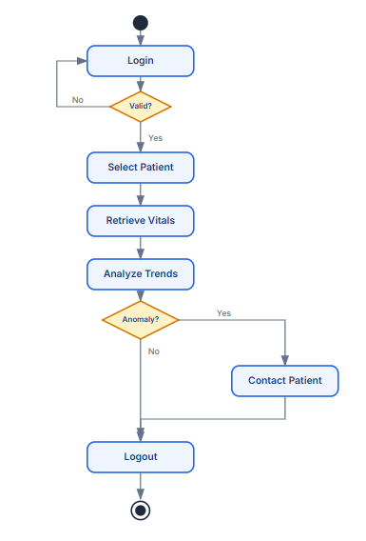
Figure 3.8: Activity Diagram for Doctor Review
3.9 Security and Privacy Design
3.9.1 User Authentication and Authorization
Access to the system is strictly controlled through authentication mechanisms. Users must provide a valid email and password to access their accounts. Authorization ensures that users can only access resources appropriate to their role; for example, patients cannot view other patients' data, and only doctors can view the master patient list.
3.9.2 Patient Data Privacy and Confidentiality
To maintain confidentiality, the system limits data visibility. The architecture is designed such that personal identifiers are handled with care. The system adheres to principles of data minimization, collecting only what is necessary for maternal monitoring (Bello & Danjuma, 2024).
3.9.3 Data Encryption Techniques
Sensitive data such as passwords are not stored in plain text. The system utilizes hashing algorithms like Bcrypt to encrypt passwords before storage in the database. This ensures that even if the database is compromised, user accounts remain protected. Additionally, the application is designed to run over HTTPS to encrypt data in transit between the client browser and the server.
3.9.4 Secure Data Transmission
Secure data transmission is achieved by validating all inputs on both the client side (using JavaScript) and the server side (using PHP) to prevent SQL injection and Cross Site Scripting (XSS) attacks. This ensures that malicious data cannot be transmitted to the database to corrupt the system.

3.10 Database Design
3.10.1 Database Management System Used
The system utilizes MySQL as the Database Management System. MySQL was chosen for its reliability, open-source nature, and seamless integration with PHP. It supports the relational data model required to link patients with their respective health records.
3.10.2 Database Schema Design
The schema is designed to ensure data integrity and minimize redundancy. It uses a relational model where tables are linked via primary and foreign keys. For example, the 'vital_signs' table contains a foreign key referencing the 'users' table to associate health data with the correct patient.
3.10.3 Database Tables
The primary tables in the database include:
Table Name | Description
users | Stores login credentials and role information.
patient_profiles | Stores specific details like age and medical history.
vital_signs | Stores the daily logs of health parameters.
doctor_notes | Stores comments made by doctors on patient records.

3.10.4 Description of Database Tables
Table 1: users Table
Field Name | Data Type | Constraint | Description
user_id | INT | PRIMARY KEY, AUTO_INCREMENT | Unique identifier for the user.
email | VARCHAR(100) | UNIQUE, NOT NULL | User's email address used for login.
password_hash | VARCHAR(255) | NOT NULL | Securely hashed password string.
role | ENUM | NOT NULL | Specifies user role ('patient', 'doctor').
created_at | TIMESTAMP | DEFAULT CURRENT_TIMESTAMP | Date and time the account was created.

Table 2: patient_profiles Table
Field Name | Data Type | Constraint | Description
profile_id | INT | PRIMARY KEY, AUTO_INCREMENT | Unique identifier for the profile.
user_id | INT | FOREIGN KEY | Links to user_id in the users table.
full_name | VARCHAR(100) | NOT NULL | The full legal name of the patient.
date_of_birth | DATE | NOT NULL | Patient's date of birth.
edd | DATE | NOT NULL | Expected Delivery Date of the pregnancy.
genotype | VARCHAR(5) | NULL | Blood genotype of the patient.

Table 3: vital_signs Table
Field Name | Data Type | Constraint | Description
log_id | INT | PRIMARY KEY, AUTO_INCREMENT | Unique identifier for the vital log.
patient_id | INT | FOREIGN KEY | Links to user_id in the users table.
systolic_bp | INT | NOT NULL | Upper reading of blood pressure.
diastolic_bp | INT | NOT NULL | Lower reading of blood pressure.
weight | DECIMAL(5,2) | NOT NULL | Patient's weight in kilograms.
fetal_moves | INT | NOT NULL | Number of fetal movements recorded.
created_at | TIMESTAMP | DEFAULT CURRENT_TIMESTAMP | Date and time the log was submitted.

Table 4: doctor_notes Table
Field Name | Data Type | Constraint | Description
note_id | INT | PRIMARY KEY, AUTO_INCREMENT | Unique identifier for the note.
patient_id | INT | FOREIGN KEY | The patient being reviewed.
doctor_id | INT | FOREIGN KEY | The doctor writing the note.
note_content | TEXT | NOT NULL | The medical advice or observation.
created_at | TIMESTAMP | DEFAULT CURRENT_TIMESTAMP | Date and time the note was written.

References
Amadi, C., Okon, E., & Uche, P. (2023). Electronic health records and patient safety in Nigerian hospitals. Journal of Medical Informatics, 15(2), 45-58.
Bello, A., & Danjuma, K. (2024). Data privacy and security in Nigeria’s digital health ecosystem. Nigerian Journal of Technology, 43(1), 89-102.
Chukwu, E., & Eze, T. (2024). Cost benefit analysis of telemedicine in rural Nigeria. African Journal of Health Economics, 12(3), 112-125.
Ibrahim, F., & Yusuf, A. (2021). Workload analysis of healthcare professionals in public antenatal clinics. West African Journal of Medicine, 38(4), 201-210.
Oluwaseun, O., & Musa, A. (2022). Evaluation of manual record keeping in Nigerian primary health centers. Journal of Health Information Management, 10(1), 22-34.

